**-22AIE442-  
Robotics operating systems**

**Name: Girish S Roll No: AM.EN.U4AIE22044**

# **Labsheet 4**

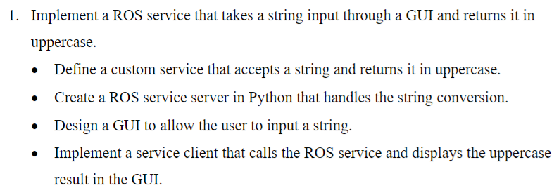

**Server:**

#!/usr/bin/env python3

import rospy

from lab4.srv import Uppercase, UppercaseResponse

def handler(req):

    rospy.loginfo("Received string: %s", req.input)

    return UppercaseResponse(req.input.upper())

def server():

    rospy.init_node('uppercase_service')

    service = rospy.Service('convert_to_uppercase', Uppercase, handler)

    rospy.loginfo("Service for converting string to uppercase")

    rospy.spin()

if __name__ == "__main__":

    server()

**Client:**#!/usr/bin/env python3

import rospy

from lab4.srv import Uppercase

def client(input_string):

    rospy.wait_for_service('convert_to_uppercase')

    try:

        upper = rospy.ServiceProxy('convert_to_uppercase', Uppercase)

        result = upper(input_string)

        return result.output

    except rospy.ServiceException as e:

        print("Service Failed")

if __name__ == "__main__":

    rospy.init_node('uppercase_client')

    while True:

        string = input("Enter a string to convert: ")

        result = client(string)

        rospy.loginfo("Uppercase result: %s", result)

**Output:**

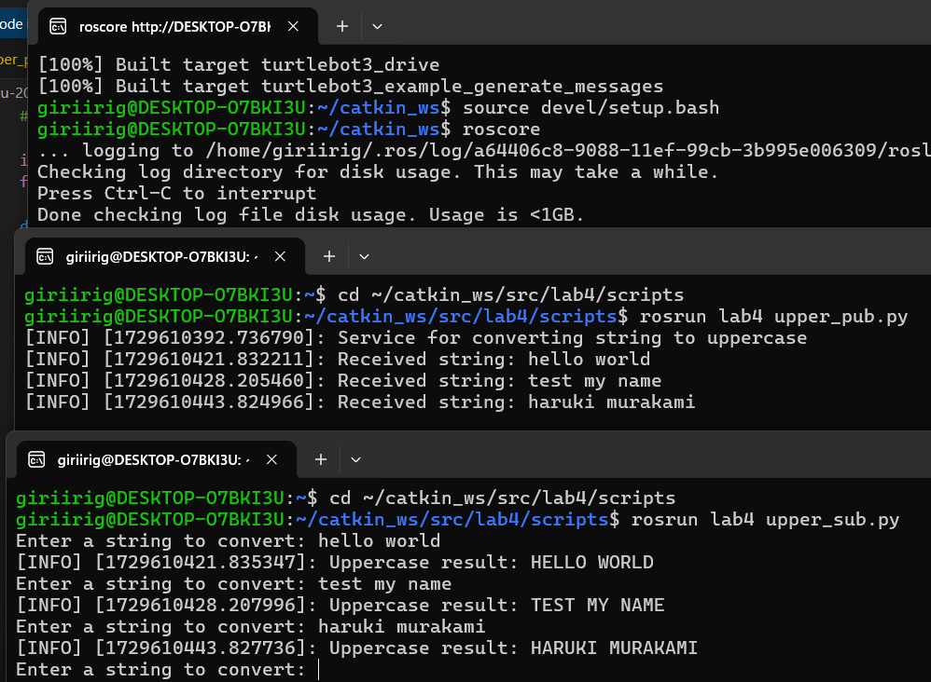

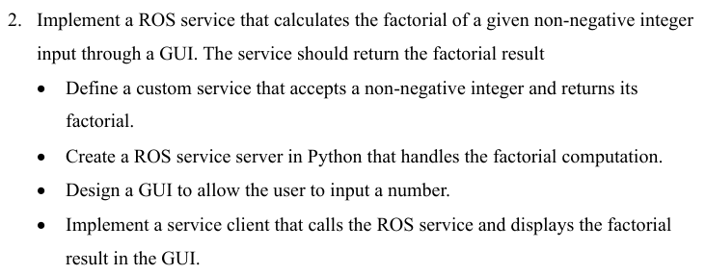

**Input:  
Server:**#!/usr/bin/env python3

import rospy

from lab4.srv import Factorial, FactorialResponse

import tkinter as tk

fact = lambda n: 1 if n < 2 else n * fact(n - 1)

def handle(req):

    rospy.loginfo("Received Num: %s", req.input)

    return FactorialResponse(fact(req.input))

def start_server():

    rospy.init_node('server')

    rospy.Service('Factorial', Factorial, handle)

    root = tk.Tk()

    root.title("Factorial Server")

    root.geometry("300x150")

    l = tk.Label(root, text="Server is running...")

    l.pack(pady=20)

    while not rospy.is_shutdown():

        root.update()

if __name__ == "__main__":

    start_server()

**Client:**

#!/usr/bin/env python3

import rospy

from lab4.srv import Factorial

import tkinter as tk

from tkinter import messagebox

def call_service():

    global e

    try:

        n = int(e.get())

        rospy.wait_for_service('Factorial')

        service = rospy.ServiceProxy('Factorial', Factorial)

        res = service(n)

        rospy.loginfo("Factorial: %s", res.output)

        messagebox.showinfo("Factorial Result", f"The factorial is: {res.output}")

    except Exception as e:

        messagebox.showerror("Error", f"Unexpected error: {e}")

if __name__ == "__main__":

    rospy.init_node('client')

    root = tk.Tk()

    root.title("Factorial Client")

    root.geometry("300x200")

    l = tk.Label(root, text="Enter a Number:")

    l.pack(pady=10)

    e = tk.Entry(root, width=40)

    e.pack(pady=5)

    b = tk.Button(root, text="Calculate", command=call_service)

    b.pack(pady=10)

    root.mainloop()

**Output:**

